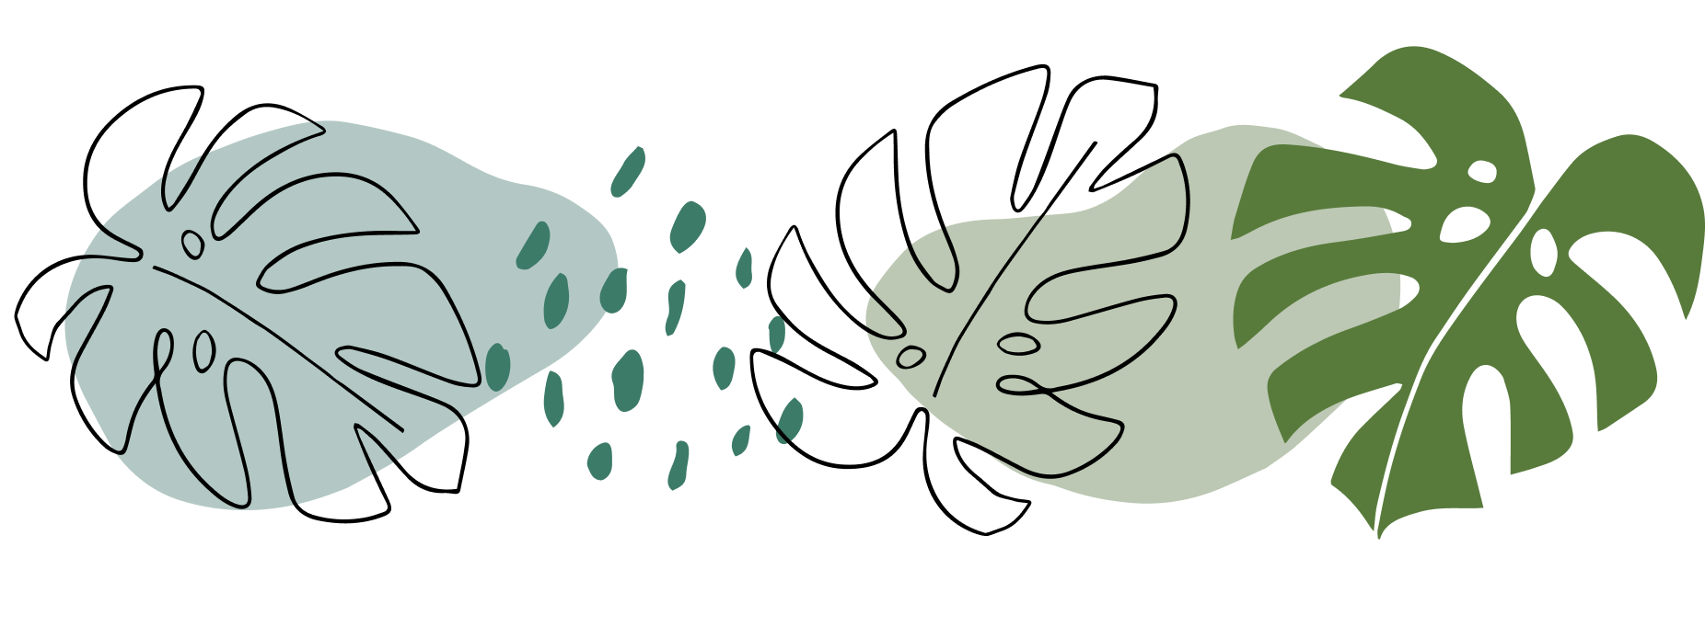

An IoT Based Plant Watering System Using ThingSpeak

# Abstract:

Watering plants, whether on a large scale or in a garden is a difficult task, leading to issues such as overwatering, underwatering and inefficiencies in resource usage. This issue is not limited to individual gardeners but extends to farmers grappling with acres of land, labouring through sun, wind and rain. Traditional watering methods consume a significant amount of time and are reliant on manual intervention.

Motivated by these challenges, we propose an IoT based plant watering system, consisting of a prototype featuring major components like: NodeMCU ESP8266 Microcontroller, a soil moisture sensor, and an LCD screen to display real-time readings integrated with ThingSpeak.

Some of the major findings and conclusions that can be noted are:

* Scalability for Larger Applications: Our prototype can be taken further (on a larger scale) to be integrated sophisticated irrigation systems like drip irrigation, offering a scalable and efficient solution to farmers.
* User-Friendly: Thing offers an intuitive and interactive user interface, which emphasizes the importance of accessible technology for managing plant irrigation.
* Real-time monitoring Capabilities: Users are kept updated about the moisture levels of their plants through the Blynk app and can take prompt actions as needed.
* Water Conservation Impact: The emphasis on instant shut-off and precision watering contributes to water conservation, which is particularly relevant given the growing concerns about water scarcity in some parts of the world.
* Promotion of Sustainable Agriculture: This project optimizes water usage, reduces manual labour and minimizes the environmental impacts due to inefficient watering practices.
* Efficiency and Precision in Water Usage: This addresses the challenge of determining precise water needs of plants, avoiding both overwatering and underwatering.

Thus, our prototype provides an immediate solution for individual gardeners and farmers, and lays foundation for a more extensive implementation in agriculture. By harnessing IoT, this system has the potential to revolutionize traditional irrigation methods, offering a more sustainable and precise approach to water management in agriculture.

# Introduction:

##### Background:

Watering your garden is a laborious task, you never know how much to water your plants. Even farmers face the same issue, and they have acres of land to cover, all while physically weathering through the sun, wind and rain.

Traditional watering methods are not only time and resource consuming, but often result in overwatering, underwatering and the need of human intervention.

Thus, this motivated us to create a prototype of an automated watering system that could:

* Release the right amount of water based on the soil moisture readings (through the app)
* Direct the water exactly where it is needed (to the roots, and nowhere else)
* Instant shut off using Blynk to keep water usage to a minimum.

The benefits of this system include:

* Reduced labour costs: The system can automate the irrigation process, which can save farmers a lot of time and money.
* Improved water efficiency: The system can use sensors to determine when and how much water is needed, which can help farmers to save water and money.
* Increased crop yields: By watering the fields more evenly and efficiently, farmers can improve crop yields and quality. This can lead to increased income for farmers.
* Reduced environmental impact: By using less water and fertilizer, the system can help to reduce the environmental impact of agriculture.

##### Problem Statement:

India is a predominantly agricultural country, with over 50% of the population employed in the sector. However, agriculture in India is facing a number of challenges.

Traditional irrigation systems for large fields in India are often labour-intensive and time-consuming. Farmers must manually open and close valves and walk long distances to check on the irrigation system. This can be especially difficult during hot weather and when the fields are large. Traditional methods often lead to uneven distribution of water and are inefficient and wasteful, often leading to overwatering of plants or leaving them underwatered. This can lead to plant death, soil erosion, and water pollution.

A smart watering system using IoT and a mobile application, Blynk can help to address all of these challenges.

##### Proposed Solution:

The proposed solution for this project is a smart watering system using IoT and Blynk that can be controlled remotely via a mobile app. The system will use a NodeMCU with the ESP8266 WiFi module to connect to the internet and the Blynk cloud. A soil moisture sensor will be used to detect the moisture level of the soil, and a relay module will be used to control a water pump.

The system will operate as follows:

1. The NodeMCU will periodically read the soil moisture sensor.
2. If the soil moisture level is below a certain threshold, the NodeMCU will turn on the water pump.
3. The water pump will run for a predetermined amount of time, or until the soil moisture level reaches a certain level.
4. The NodeMCU will then turn off the water pump.
5. The NodeMCU will continue to monitor the soil moisture level and repeat this process as needed.

The user can also manually turn the water pump on and off using the Blynk app.

**The system can be implemented using the following components:**

* NodeMCU with ESP8266 WiFi module
* Soil moisture sensor
* Relay module
* Water pump
* Blynk app

The NodeMCU will need to be programmed to read the soil moisture sensor and control the water pump. This can be done using the Arduino IDE.

The Blynk app will need to be configured to display the soil moisture level and allow the user to manually turn the water pump on and off.

##### Innovative Features of the Project:

By automating irrigation and providing real-time monitoring of soil moisture levels, a smart watering system can help farmers to save water, improve crop yields, and reduce costs.

In addition, a smart watering system can be controlled remotely using a mobile app. This means that farmers can monitor their plants and adjust the irrigation system from anywhere, even if they are not physically present on the farm.

Here are some innovative features that could be added to a smart watering system:

* Remote Monitoring: The system allows remote monitoring and controlling the water. This allows users to check the status of their plants and adjust the watering schedules from anywhere, using smartphones. This is particularly useful for urban gardeners or people who travel.
* Water Conservation: Watering the plant till the right amount of moisture level is reached not only helps in preventing overwatering but helps conserve water resources.
* Customization: Blynk allows for a high degree of customization. Users can set up alerts, notifications and custom watering schedules based on their specific plant types and environmental conditions.
* Data Analytics: These systems can collect and analyse data overtime. Users can gain insights into plant growth patterns, moisture trends and the impact of different watering schedules.
* Scalability: IoT based plant watering systems are scalable, you can start work with a few sensors and expand as needed.

In addition to these features, innovative technologies such as artificial intelligence (AI) and machine learning (ML) could also be used to improve the performance and efficiency of a smart watering system. For example, AI could be used to train the system to recognize patterns in the data and make more accurate predictions about irrigation needs. ML could be used to optimize the irrigation schedule based on a variety of factors, such as weather conditions, soil moisture levels, and plant growth stage.

# Methodology:

Objective:

An automated plant watering system using Blynk Platform to ensure optimal moisture levels in soil. It has real-time monitoring of moisture levels in the soil, and remote-controlled watering, using Blynk. The end-users can be regular gardeners or farmers, if this project is taken up on a large scale.

Hardware Requirements:

|  |  |
| --- | --- |
| * Soil Moisture Sensor: To sense moisture levels in the soil. |  |
| * Microcontroller: We use the NodeMCU ESP8266 microcontroller. |  |
| * Water Pump: To control the water flow to the plants. |  |
| * Power Supply: We use a battery to power the entire system. |  |
| * Jumper Wires: Used to connect sensors, actuators and microcontrollers. |  |
| * LCD Screen: To display the real-time sensor output. |  |
| * Relay Module: Acts as a switch between the electrical load and NodeMCU. |  |
| * I2C module: Helps reduce the number of GPIO (General Purpose Input/Output) pins. |  |
| * Breadboard: Used to build the entire circuit. |  |

Software Requirements:

* Blynk App: Make sure that the app is installed and configured on the user’s phone.
* Blynk libraries: Install the Blynk libraries compatible with the selected microcontroller.
* Arduino IDE: To program the microcontroller.
* Internet Connectivity: Reliable internet connectivity for remote monitoring

Procedure:

1. Attach the NodeMCU on the breadboard and connect the Vin and GND to the breadboard.

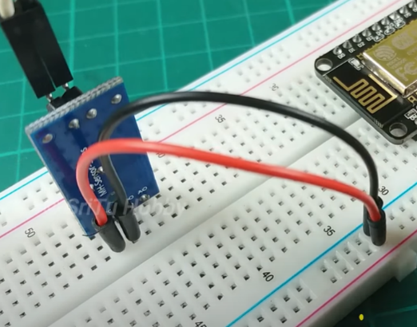 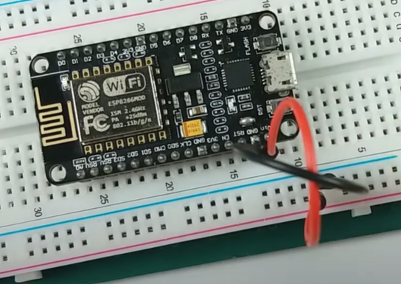

1. 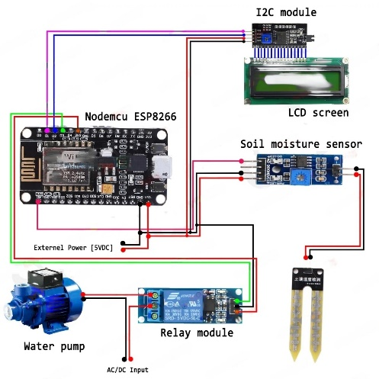Place the soil moisture sensor on the breadboard and connect it to the NodeMCU board. Use the circuit diagram attached.
2. Connect the LCD display and the relay module to the NodeMCU board.

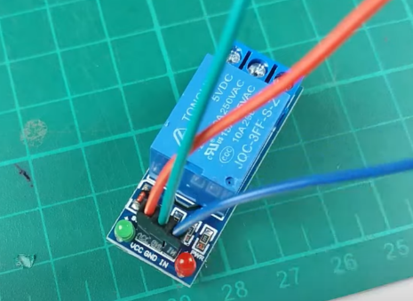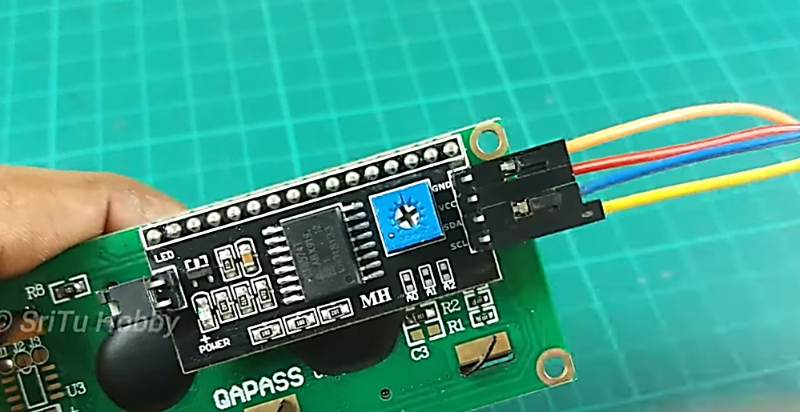

1. Create a Blynk web dashboard. Follow the steps below:

* Navigate to the Blynk website, and create a new account. Sign into your account and click the new template button. Enter your project name and click done.

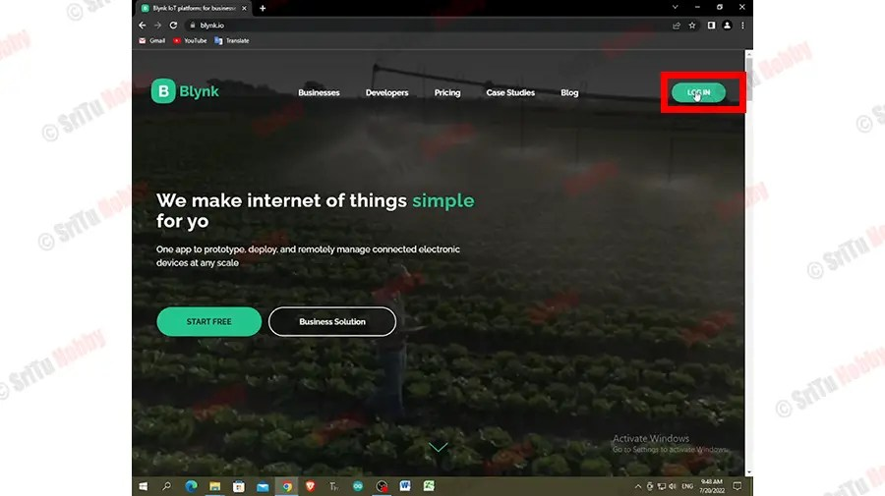 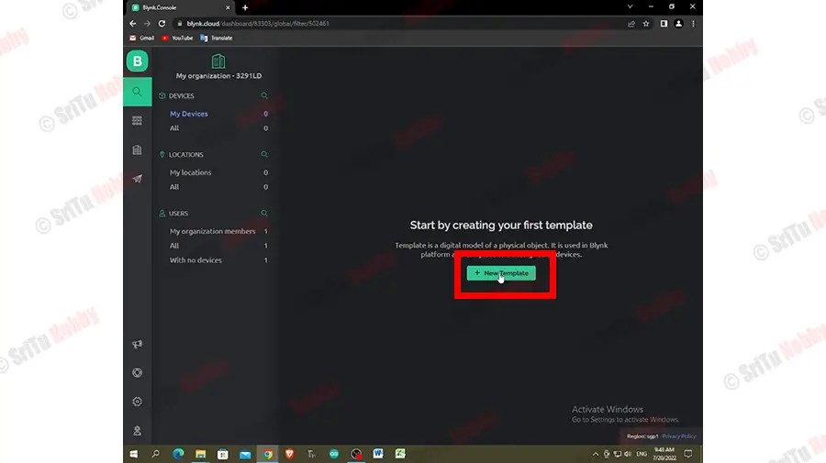

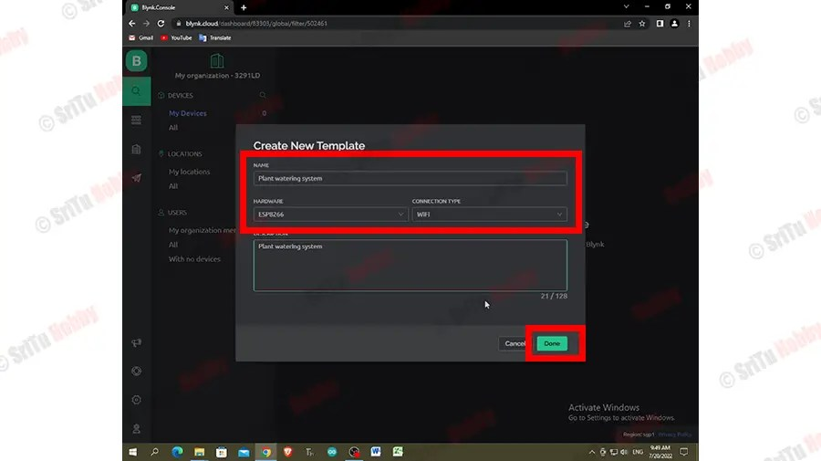

* Click “Datastreams” tab and create two data streams for that.

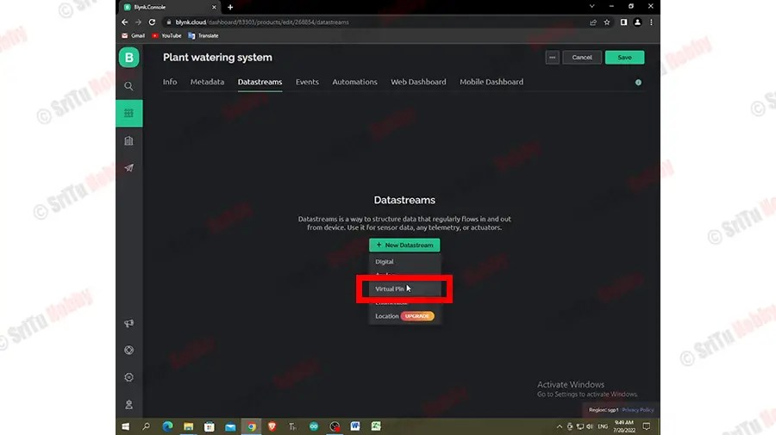 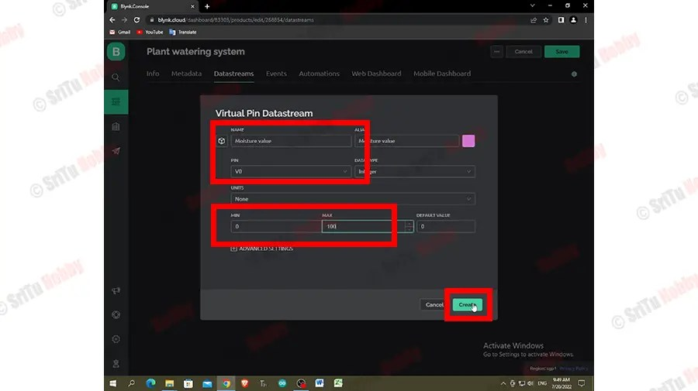

* Click the “Web dashboard” tab and include the one button and one Gauge widget to the dashboard.

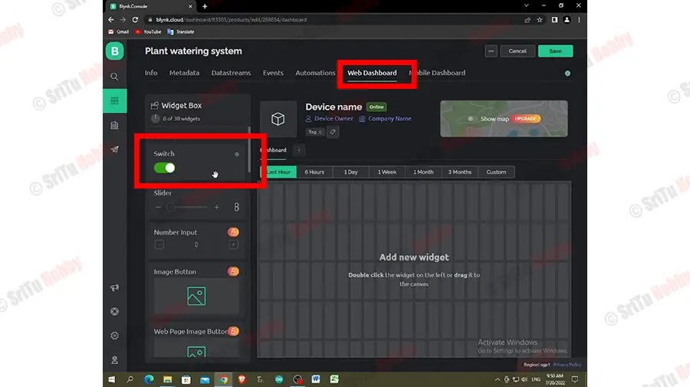 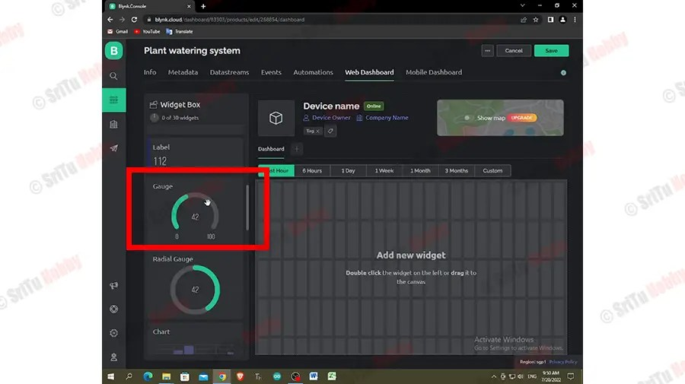

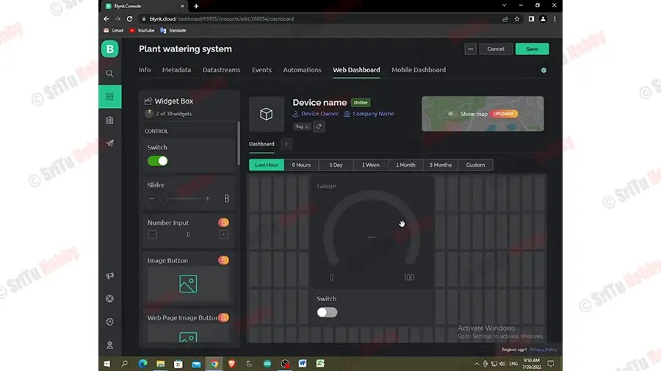

* Click the one-by-one settings buttons on these widgets and select the data streams we created earlier. After click the save button.

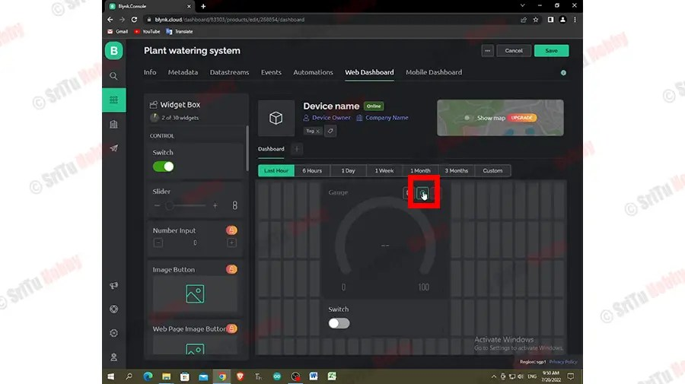 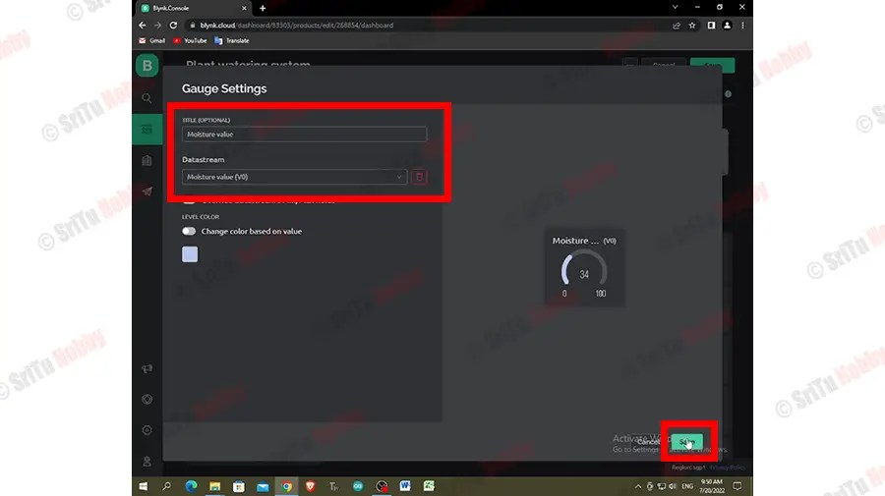

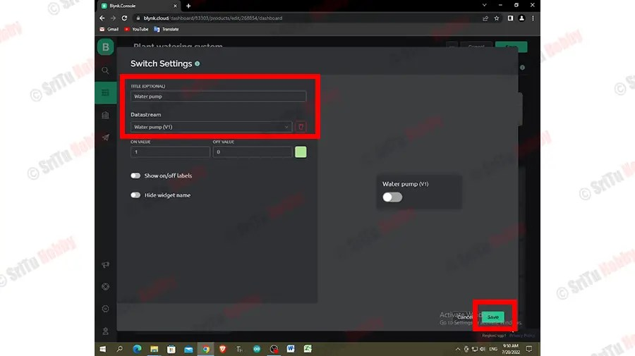 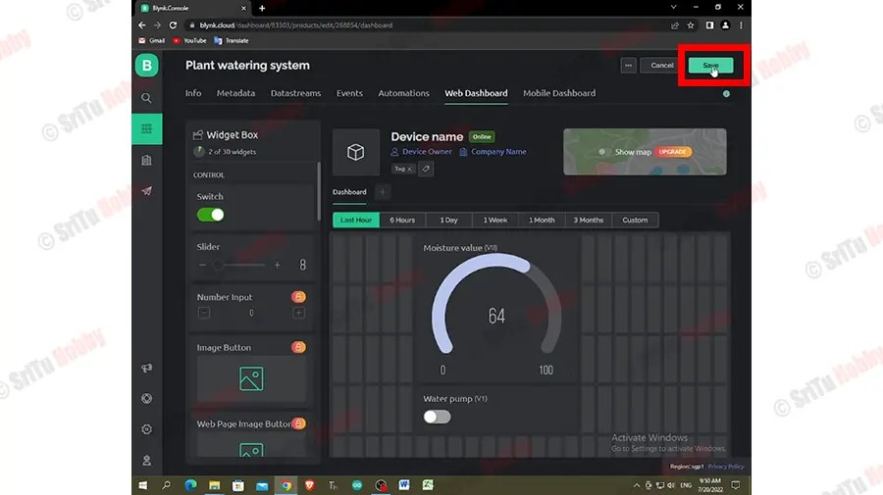

* Click the search icon button and create a “new device”. Select the template you created earlier.

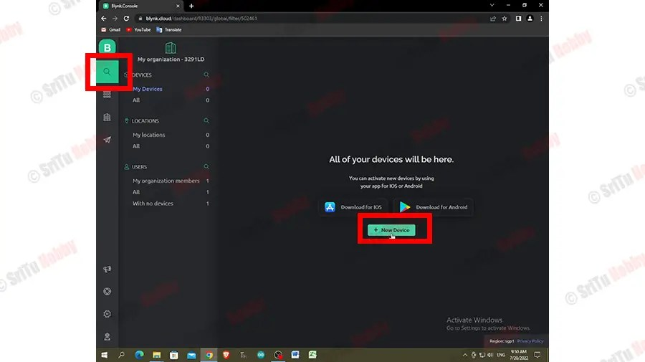 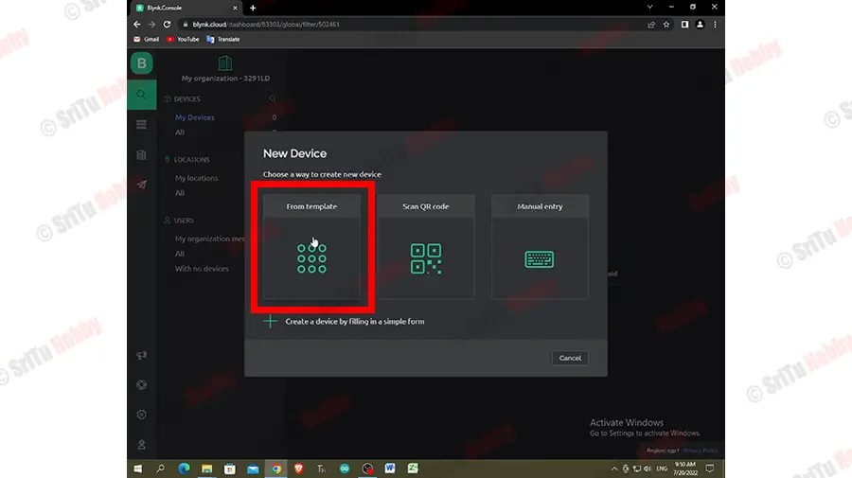

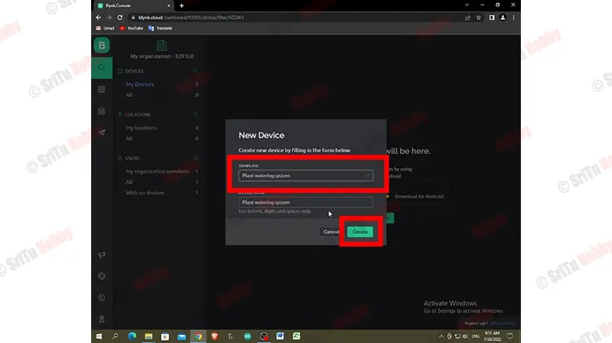

1. Connect this project to the computer and upload the program for this project.

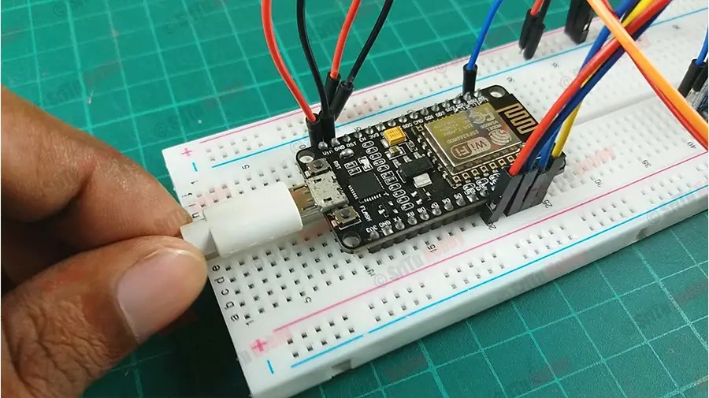

* Copy and paste the Blynk authentication token. Its in the Blynk web dashboard.

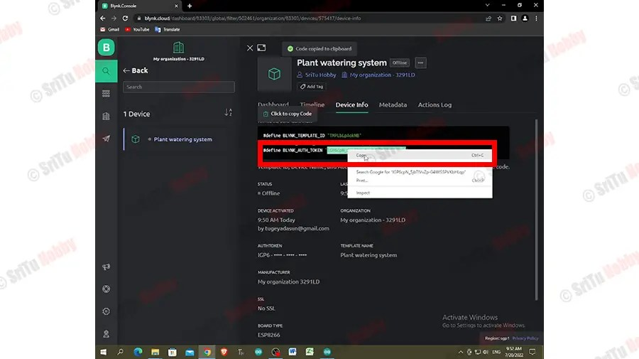

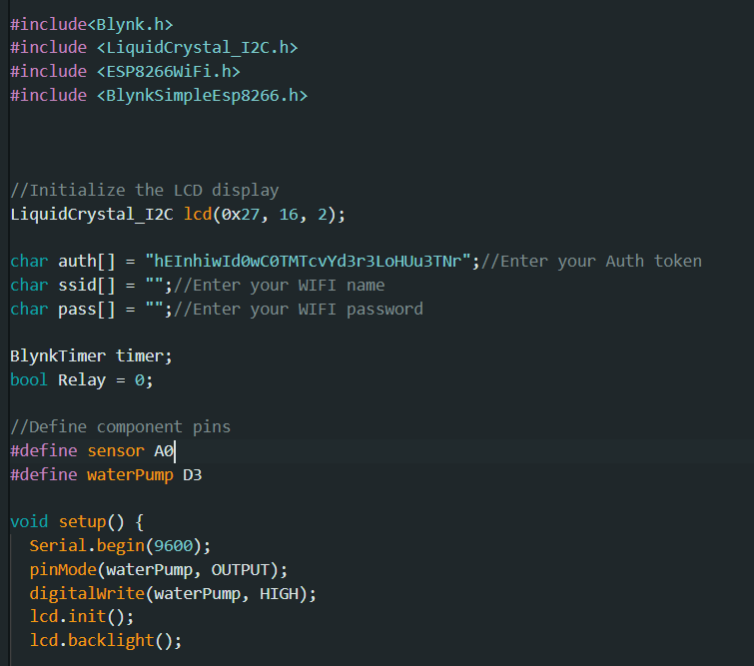

* Enter WiFi SSID and password. Select board. Upload this code to the NodeMCU board.

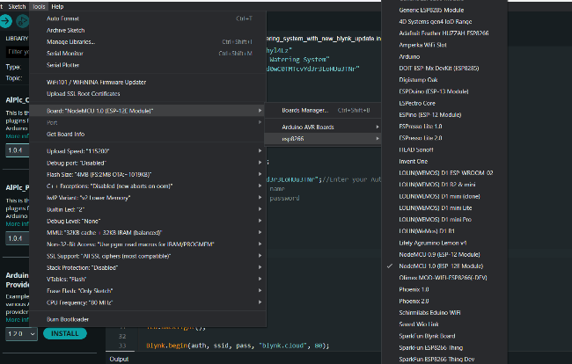 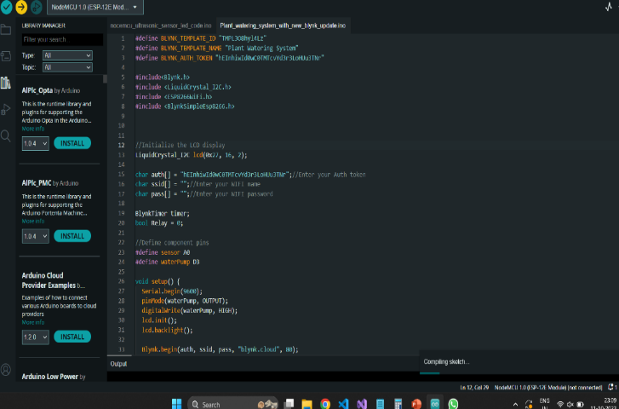

1. Create the Blynk mobile dashboard.

* Download and install the Blynk app. Sign into your account and click the template you created in the dashboard.
* Add the widget to the dashboard. Click the + icon at the top right corner. And then add one button and one gauge widget to the dashboard.
* Arrange these widgets as you like. Now click the one-by-one widget and select the data streams you just created in the Blynk web dashboard.

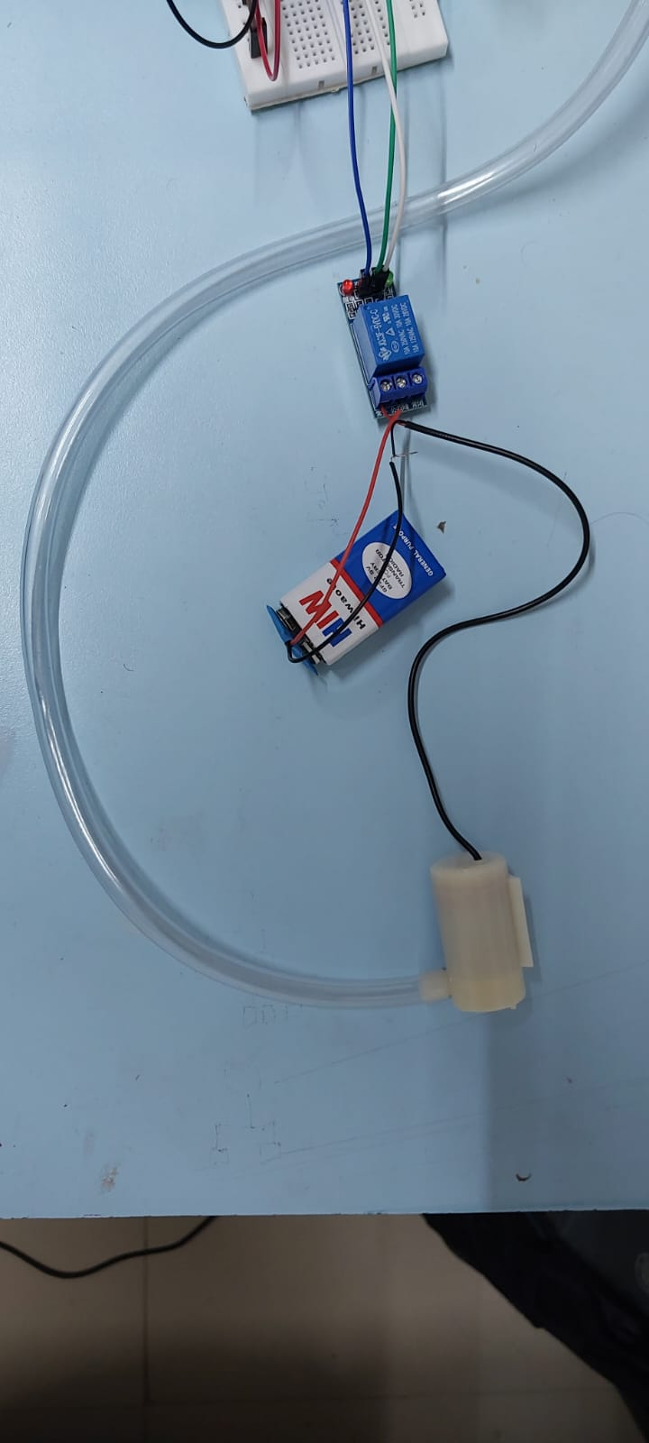

1. Connect the water pump to the relay module. Then, put the soil moisture sensor into the soil.

##### The final setup of our model:

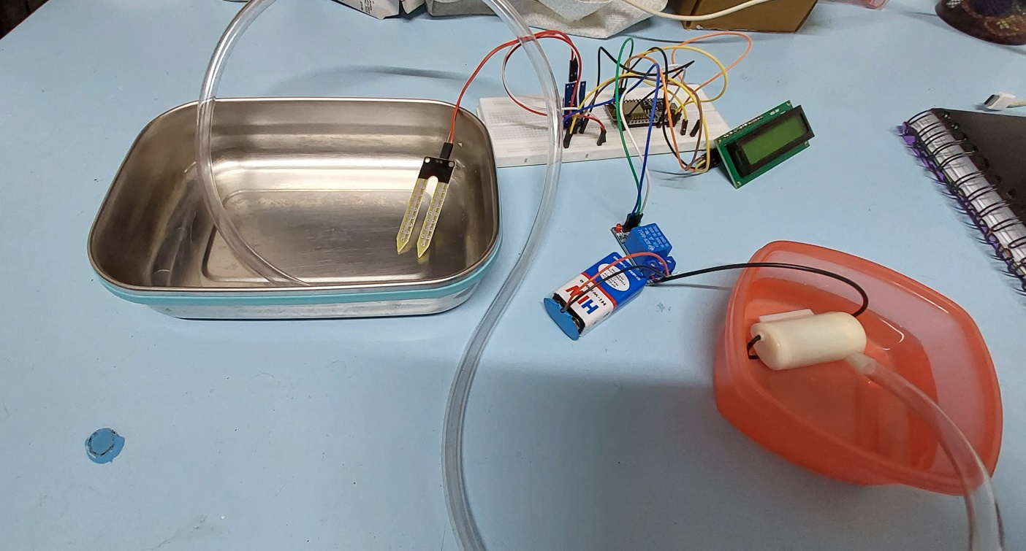

##### Conclusion:

A smart watering system with innovative features can help farmers to save water, improve crop yields, and reduce costs. It can also help to reduce the environmental impact of agriculture. By integrating with other agricultural systems and using innovative technologies such as AI and ML, a smart watering system can be made even more effective and efficient.

This system not only automates the irrigation process, but also provides real-time monitoring of soil moisture levels, making it possible to optimize water usage and enhance crop yields. This approach contributes to water conservation, reduced costs and eco-friendly farming practices.

The ability to remotely control and monitor the system through a mobile app adds convenience and accessibility to the system. The system’s potential for scalability means it can be applied in diverse settings, from small urban gardens to large agricultural operations.

This IoT based plant watering system using Blynk empowers users with the tools and data needed to make informed decisions, conserve resources and achieve healthier plant growth. As technology continues to evolve, this system will play an important role in sustainable agriculture and horticulture, contributing to a greener future.

FINAL SETUP WITHOUT WATER PUMP:

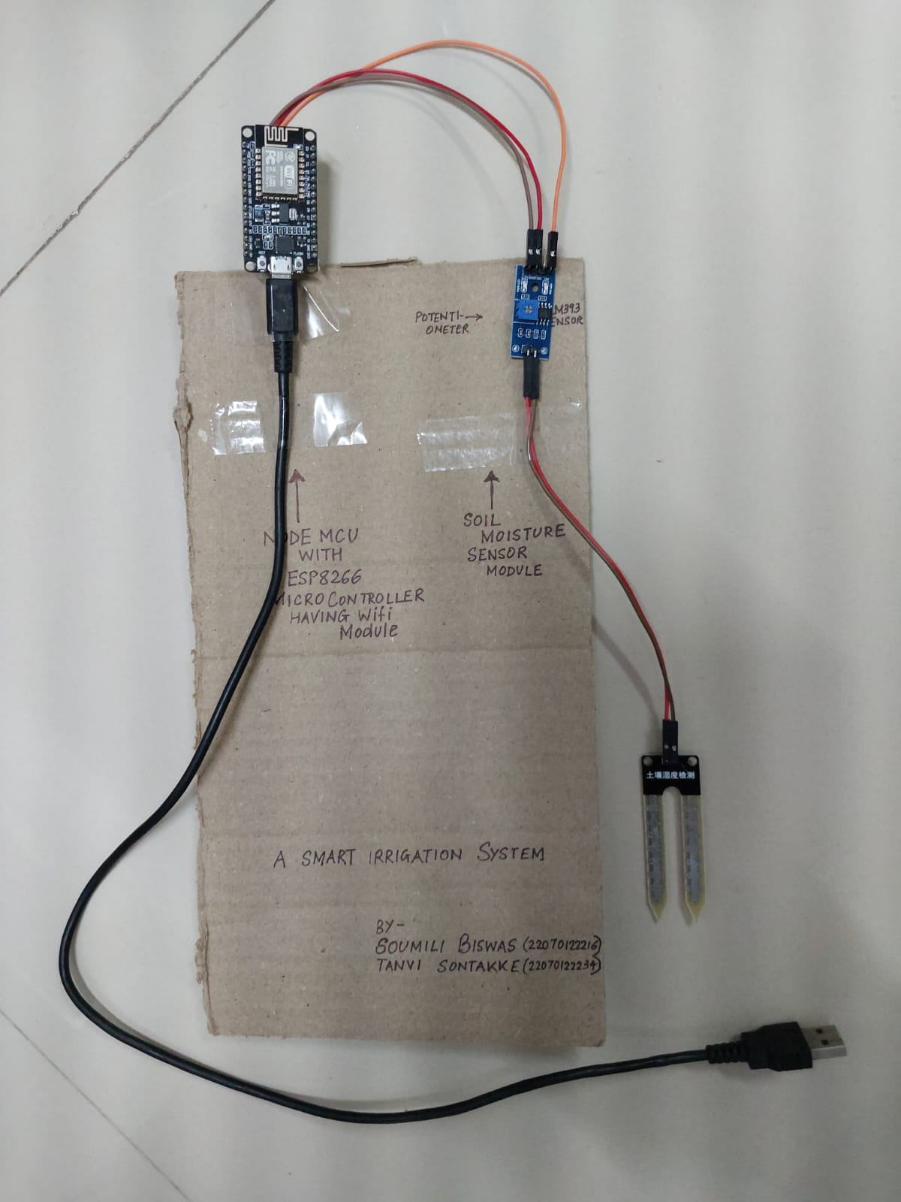

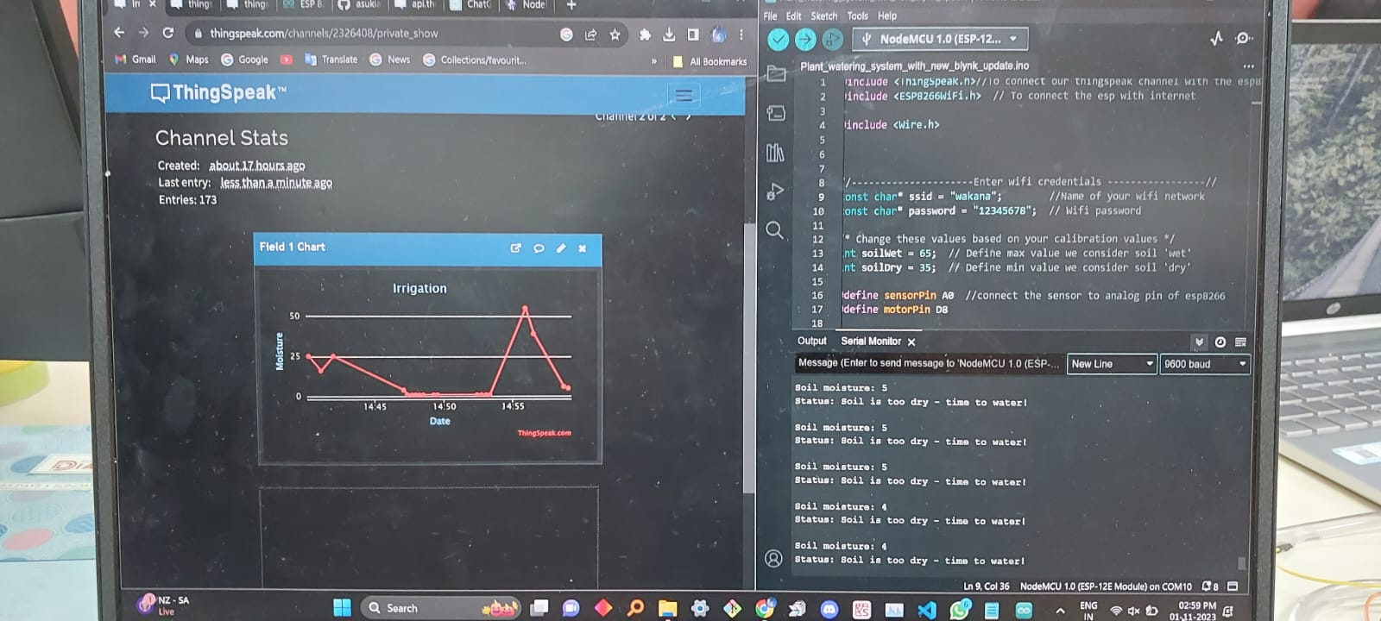OUTPUT: